Woodstocks Stock Control

User Manual

Joshua Grimmett, Skillage I.T.

# Summary

The Woodstock Stock Control Editor is a stock control program specifically designed for the business, Woodstocks, to automate their stock editing. The program is designed for users to be able to edit the current count column and restrict editing of other fields. The program loads stocks from a csv file. The location of the stocklist file can be edited in the *App.config* file.

# Interface

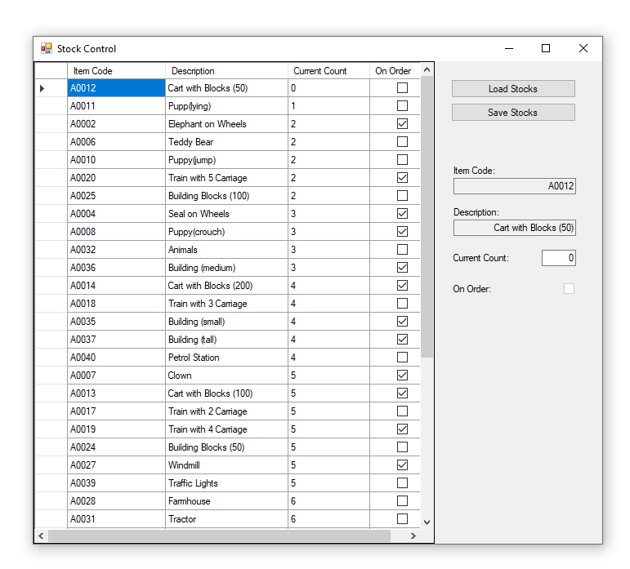

The program has a simple interface with the functionality for loading or reloading the stocks from the stocklist file, being located on the right hand side, labeled: “Load stocks”.

To then save the stocks after editing another button located on the right hand side, underneath the “Load Stocks” button, labeled: “Save Stocks”.

The main table on the left hand side shows the list of stocks. The values are separated into rows and columns, under the stock’s attributes: Item Code, Description, Current Count and On Order. Using the table the user may edit the Current Count field by selecting the Current Count cell corresponding with the stock item by entering the new value. The user can also edit the Current Count by utilising the text box on the right hand side, labeled: “Current Count”.

Functionality for row sorting is also available, by selecting the column to sort by at the top of the table. To toggle ascending order, the user may once again click the selected sorting column.